Using our new digital directory in the Church Center App:

Why are we switching to a digital directory?
- Digital directories stay up to date. Members can update information and photos whenever they need to.
- We can add new members instantly.
- As long as you have access to the internet, you have the directory with you!
- The app that the directory is on can also be used to;
  - Keep up to date on church news & events
  - Watch service videos
  - Sign up for events
  - Give tithes and offerings
  - Communicate with your teams and life groups
Is it safe?
- You must receive an invite to have access to the directory, meaning not just anybody can download the app and access the directory.

Let’s get started!

If you do not have a smart phone, you can access the app online at icrclansing.churchcenter.com and follow the same steps.

Step 1: Locate and install the Church Center App on the App Store or Google Play Store.
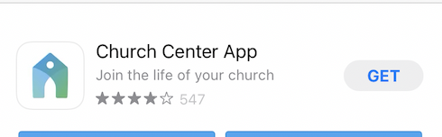

Step 2: Locate Immanuel Lansing; by searching our address (3200 Delta River Drive) or turning your location on.

Step 4: Select Immanuel Lansing

Step 5: Enter your phone number. If you’re already in our system, then you can skip to step 6.

Step 6: If you are not in our system, you will need to enter your phone number and email address and then verify your account with the code that will be emailed to you.

Step 7: Check out our home page! We will do our best to keep this page up to date with the latest news and events for our church.

Step 8: Select the directory in the lower right corner.
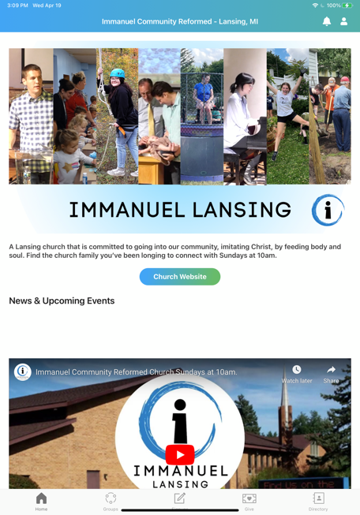

*** You must receive an invite in order to access the directory. Please let Joey know if you did no not have access.

Step 9: Select “Share now” located at the bottom in order to include your information in the directory. Then select your name, the information you want to include, and select share in the upper right-hand corner.

Step 10 (To add or edit missing information): Select the little person icon in the upper right corner. If you already have a picture in our system, this icon will be your picture.
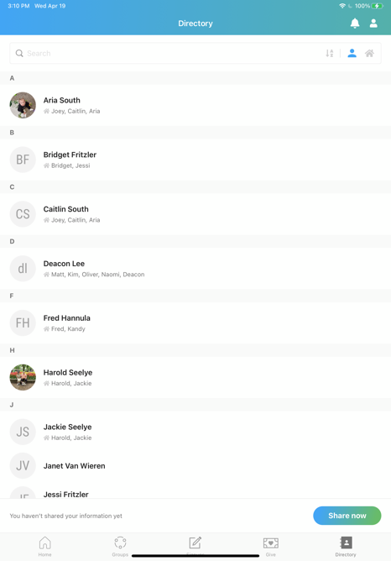

Step 11: Select your name

Step 12: Select contact and profile information

Step 13: From here you can add a current photo and fill in any missing information.

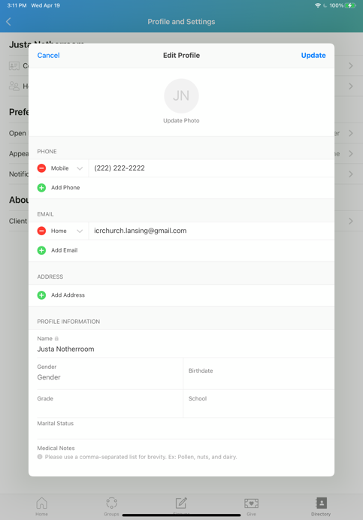

That’s it!

From now on, all you will have to do it open the app, click on the directory, and then you can search for the church member you are trying to contact.

